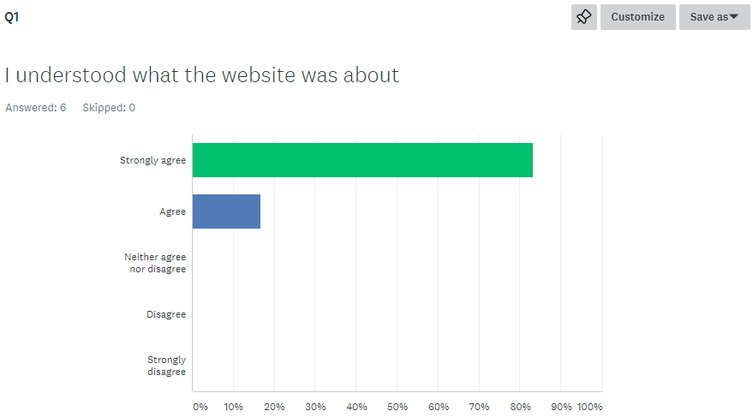

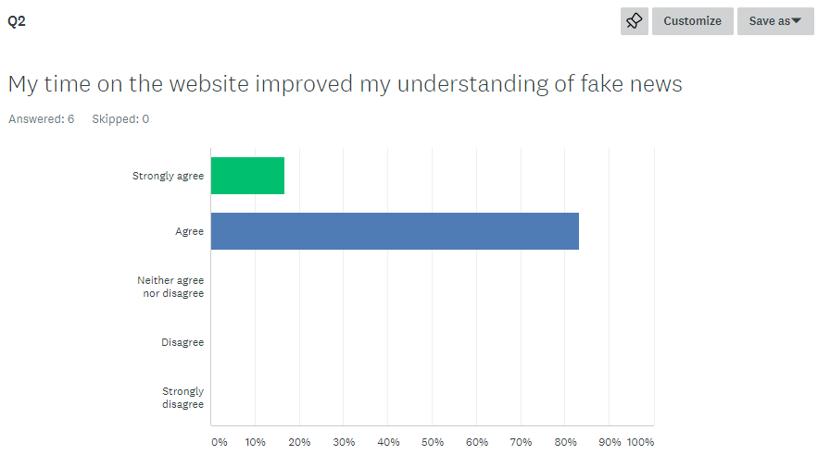

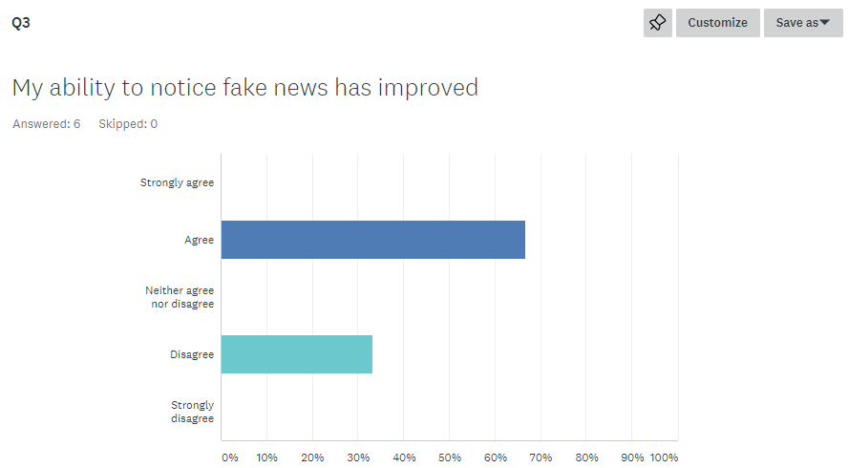

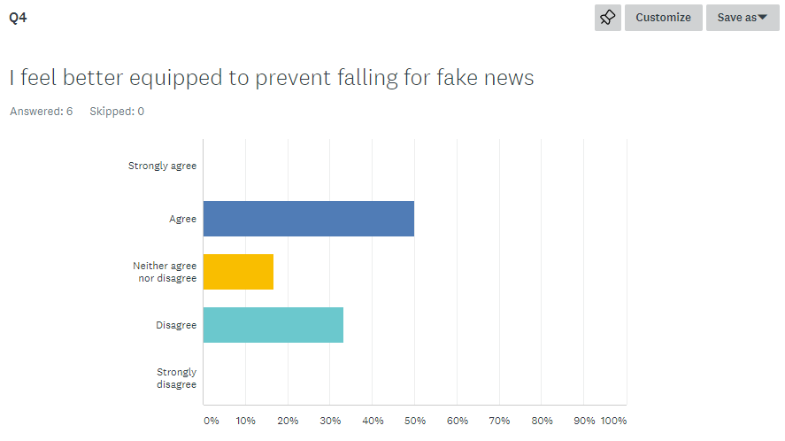

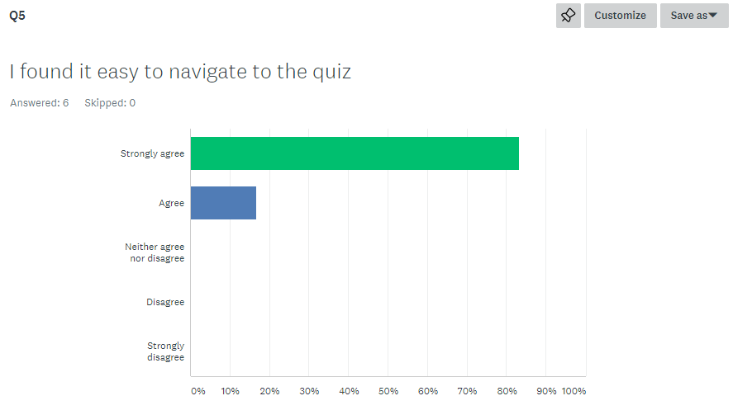

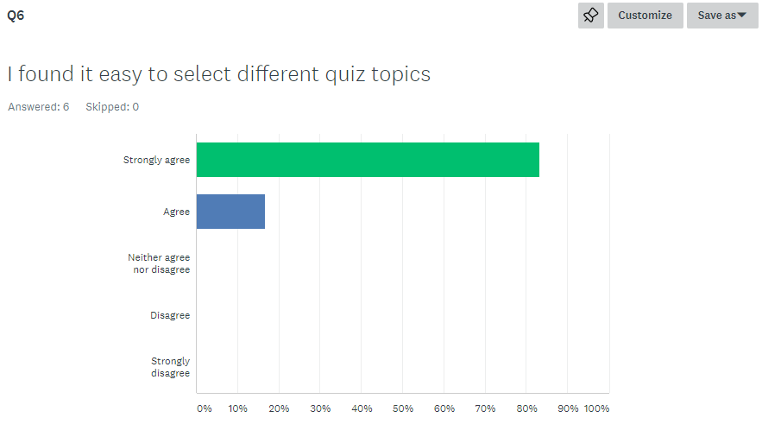

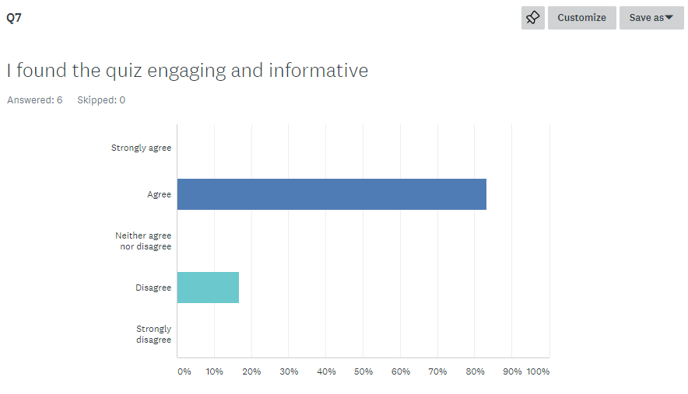

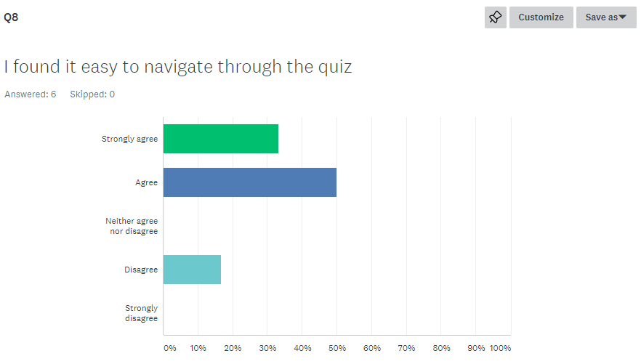

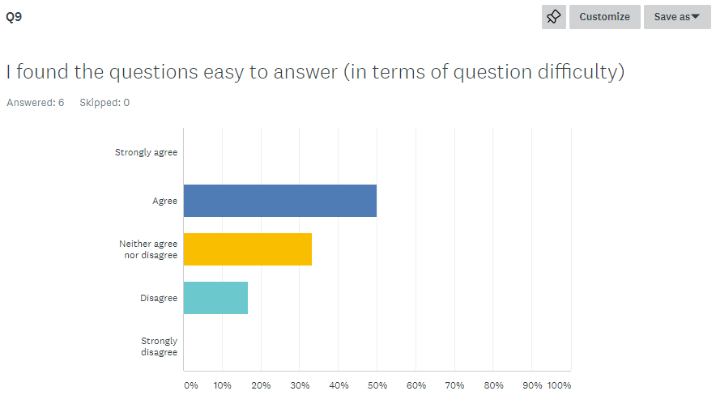

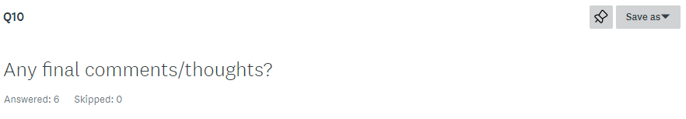

1. I thought there were too many questions for the short amount of time given, potentially 5 questions with less/same amount of time. I didn’t end up reading them all. Some of the questions were really long and quite heavy content, i would like to have seen some context to the quotes to help me understand that it meant I.e maybe dates and times they were said etc. Or maybe shorter examples for me to read quicker or summarise the examples.
2. The final level had to press submit but it also let you press next but nothing happened. Might be better for next to change to submit or not allow you to click
3. N/A
4. I don't think the quiz gave me a final mark - that would've been good I think. Also, a contents page on the 'About Fake News' page which would allow me to skip to certain sections might have been helpful as well.
5. Clean and easy to navigate site, and I now know more about fake news👍
6. - opening navigation in new tabs lead to errors - on final question next button could change to finish submit quiz or review answers - on final question last button could be disabled - quiz button in quiz could be disabled until it has a valid call to action - quiz button text could be better described, "return to quiz" - quiz page layout was nice but one item had different height for take quiz action - timer could offer extension of time if user wishes - end of quiz "clicking here" panel could use different css to make pointer a link cursor - end of quiz highlighting of fake news and how to debunk could have a stronger call visually to the user to investigate futher - end of quiz "click to debunk" opens in new tab on homepage? is that right? - call to actions on home page for go to quizes and learn more about fake news take you to middle of corresponding page, could be aligned better on landing those pages - mobile friendly slight ammendments for content size - mobile friendly ammendment for layout of navigation to maximise screen space